# *1. FizzBuzz Game*

## How it Works:

- The program generates numbers using the Fibonacci sequence (0, 1, 1, 2, 3, 5...).  
- For each number, it applies the FizzBuzz rules:  
 • If divisible by 3 → print "Fizz"  
 • If divisible by 5 → print "Buzz"  
 • If divisible by both 3 and 5 → print "Fizz Buzz"  
 • Otherwise → print the number itself  
- Player 1 (Computer) and Player 2 (User) take turns answering.  
- If anyone gives a wrong answer, the game ends immediately.  
- The computer sometimes intentionally gives a wrong answer (10% chance).

## Why it is Used:

- To combine two concepts: Fibonacci numbers and FizzBuzz rules.  
- It creates an interactive game between the computer and the user.  
- Adds randomness so the computer can also lose, making the game fun and fair.

## Output

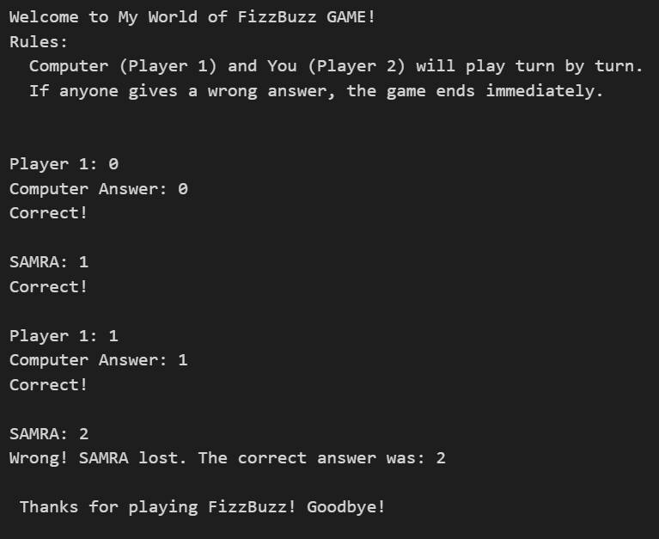

# *2. Movie Budget Calculation*

## How it Works:

- A predefined list of movies with budgets is created.  
- The user can add new movies with their budget.  
- The program calculates the total and average budget of all movies.  
- It then checks which movies have a budget higher than the average.  
- Displays how much higher each movie’s budget is compared to the average.  
- Finally, it shows the total count of movies above average.

## Why it is Used:

- To practice list operations and handling tuples in Python.  
- Demonstrates calculation of total, average, and comparison logic.  
- Provides a real-world example of analyzing movie budgets and identifying above-average ones.

## Output

